A000-ME-UR-Cylinder Seal-Ur_Nammu-Contest of Sumer and Agade-Clay-2100-2050 BCE





Figs. 1-2.

**Case no.: 2**

**Accession Number:**

**Formal Label:**

**Display Description:**

This is an Ur III period cylinder seal impression that was made from a lost cylinder seal (probably of serpentine or steatite during this period) dating to the rule of the first king of Ur III Ur-Nammu who may be the one of the figures shown in a contest between lions and wild bulls.

Ur-Nammu who, as a general and perhaps governor of Ur, succeeded to the throne after Utu-Hengal, the ruler of Uruk, had expelled war-like Gutians who had invaded Ur and Uruk from the Zagros mountains to the east after their rule spanning a period of 25 to 124 years (based on contradictory records). Ur-Nammu displayed his military prowess after being ruler of Ur for only four years when he deposed the ruler of Agade and henceforth was known as the ruler of both cities. Ur-nammu’s prowess may be the subject of this cylinder seal impression which may Ur's dominance over these cities expanded to include a Neo-Sumerian Empire which was consolidated with Ur-Nammu’s legal code, 2100–2050 BCE, the earliest extant law code surviving.

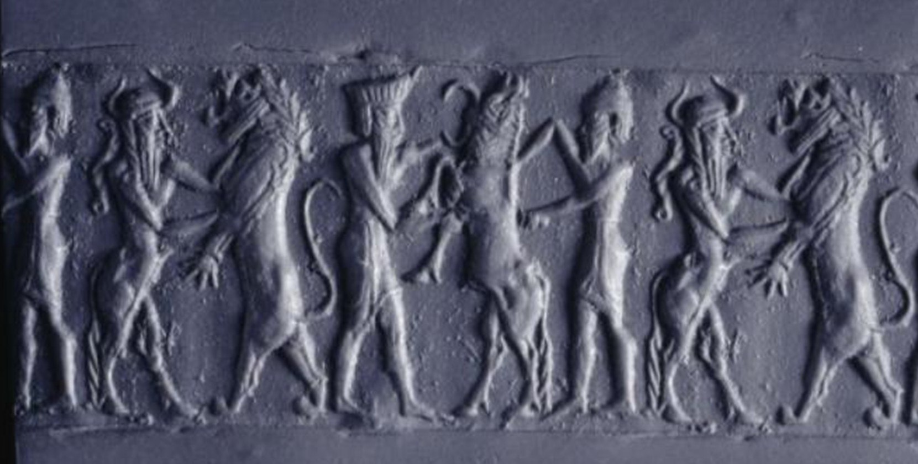Figure 3: Modern impression of a lapis lazuli cylinder seal with gold ornamental caps excavated from the Royal Cemetery at Ur (2200-2100 BCE); BM 121547 © Trustees of the British Museum. This cylinder seal impression may also be a depiction of Ur-Nammu’s rule over his two cities, metaphorically characterized as Sumer, the lion, and Agade, the wild bull.

**LC Classification:**

**Date or Time Horizon:**

**Geographical Area:**

**Map:**

**GPS coordinates:**

**Cultural Affiliation:**

**Media:**

**Dimensions:**

**Weight:**

**Condition:**

**Provenance:**

**Discussion:**

**References:**